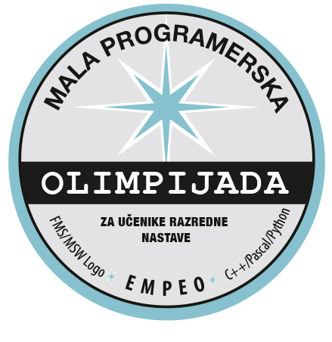
E M P E O
mala programerska olimpijada

POZVANICI

Red. | IME | PREZIME | Razred
Br. | IME | PREZIME | Razred
1 | Marta | Babić | 1.
2 | Leona | Granoša | 1.
3 | Filip | Čobanić | 2.
4 | Jakov | Blašković | 2.
5 | Karlo | Jaranović | 2.
6 | Leon | Kukovačec | 2.
7 | Gregor | Lukić | 2.
8 | Marsela | Machata | 2.
9 | Lovro Kristijan | Miljak | 2.
10 | Ensar | Modronja | 2.
11 | Imad | Modronja | 2.
12 | Josipa | Bačić | 3.
13 | Iris | Barišić | 3.
14 | Judita | Dujam Kurkut | 3.
15 | Ema | Hrkać | 3.
16 | Petar | Kožul | 3.
17 | Bruno | Lončar | 3.
18 | Ana | Mandić | 3.
19 | Juraj | Mandić | 3.
20 | Roko | Tolić | 3.
21 | Antonio | Valek | 3.
22 | Juraj | Babić | 4.
23 | Andrija | Ćavar | 4.
24 | Fran | Kokotović | 4.
25 | Jan | Lacković | 4.
26 | Dora | Lendvaj | 4.
27 | Mirta | Machata | 4.
28 | Mateo | Marinić | 4.
29 | Janko | Šeler | 4.
30 | Roko | Runjić | 4.
31 | Marko | Šimanović | 4.
32 | Leon | Pavić | 4.
33 | Dante | Postonjski | 4.

